
FINAL PROJECT HANDbook
Programming ADV Topics in Programming
Survival Guide For DJJJ

November 28, 2025
DJJJ
NSCC Ecampus Programing Year 2

Names: Dawson Brown, Judah Csanyi, Joshua Leslie, Jeremy Paruch
Student Numbers: W0468898, W0509673 , W0228010, W0222971
Due Date: November 28, 2025
Course: PROG 2200 – Adv Topics In Programming
Instructor: Nadia Gouda

Table of Contents
Adv Top 3
Project Idea Selection 3
OOP Planning Structure 4
Hierarchy diagram 4
SYSTEM DESCRIPTION 5
One Page Explanation 6
Main Purpose 6
Target users 6
Major Components 6
Expected features 6
How logic and events will work 7
The Group Policy (Ethos) 8
Commitment to Participation 8
Respect and Communication 8
Accountability 8
Quality 8
Support 8
The Group Policy Continued (Ethos) 9
Conflict Resolution 9
Transparency 9
Work-Life Balance 9
Decision-Making Process 9
Who is taking care of what? 10
Dawson 10
Jeremy 10
Josh 10
Judah 10

Adv Top

Project Idea Selection
We are doing a Library Borrowing Tracking System.
This idea was amongst us based past familiarity and comfortability with implementing the logic behind a system with this amount of sophistication,

OOP Planning Structure

Hierarchy diagram
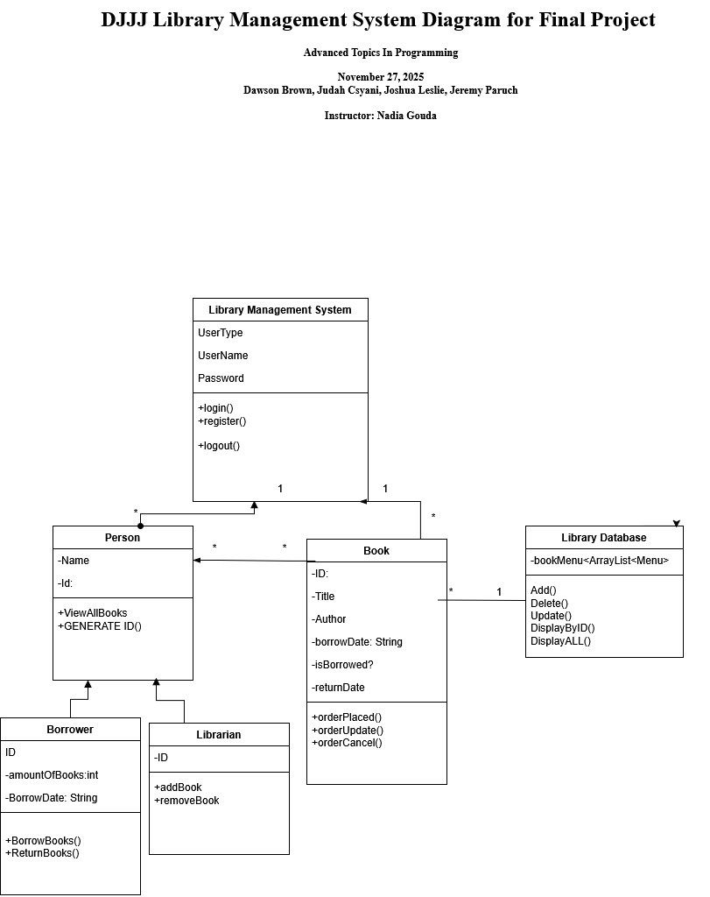

SYSTEM DESCRIPTION
Write a one page description that includes:
• Main purpose of the system
- The main purpose is to organize, track and remind librarians and borrowers of what books are currently available and unavailable.

• Target users
- Rated E for everyone
• Major components
- Library DB, Login system, Menu for viewing books, status of books, overdue books
• Expected features
- Current borrowed books, books that have been returned, books that have YET to be returned.
• How logic and events will work
If book is available{ show as available}
Else{ book is not available}
If person tries to borrow {protect with user login
}

One Page Explanation

Main Purpose
The main purpose of the Library Management System is to demonstrate our knowledge and understanding of the advanced topics in OOP ,The library management system is an exemplary project. As it’s primary function is to organize, track and remind librarians and borrowers of what books are currently available and unavailable.

Target users
The target users are everyone that is registered into the library management system. This involves librarians and “borrowers”, in this context are individuals who are successful applicants and are allowed to borrow as many books as they wish from the library. Librarians are individuals who posses the administrative rights to add, remove and update books as they deem necessary for their role.

Major Components
The major components to this project are the following:
“Library DB”,” Login System”, “Menu for Viewing Books”, “Status of Books”, and lastly “Overdue Books”.

Expected features
We are implementing the following features for this project:
“Current borrowed books”, “All available books”,

How logic and events will work
This is an example of how we are thinking the logic will work for this project:
If book is available { show as available}
Else { book is not available}
If person tries to borrow {protect with user login}.
We are very confident that this logic is sound and from a high level perspective understandable in regard to what is being communicated effectively for how this system will function.

The Group Policy (Ethos)

Commitment to Participation
We will make an effort to contribute equally to our projects by attending meetings and fulfilling our responsibilities in tasks.

Respect and Communication
We aim to promote open and respectful communication so that every team member feels comfortable sharing their ideas, concerns, and feedback.

Accountability
Each of us is accountable for completing our assigned tasks in a timely manner. If an unexpected situation arises, it’s essential to inform the team early and collaborate on finding a solution.

Quality
Our goal is to deliver high-quality work instead of hurrying, as rushing could lead to errors.

Support
We will actively support each other by sharing our knowledge and offering help when someone is facing difficulties.

The Group Policy Continued (Ethos)

Conflict Resolution
In the event of disagreements, team members should tackle conflicts with a focus on solutions and aim for a compromise; if this fails, faculty intervention may be necessary.

Transparency
We will keep each other informed and updated on our progress regarding the projects.

Work-Life Balance
We will strive to avoid overworking ourselves and acknowledge the significance of taking breaks.

Decision-Making Process
We will conduct group votes before making decisions. The majority will decide; in the case of a tie, the designated tiebreaker will make the final decision on the course of action.

Who is taking care of what?

Dawson
Backend Developer

Jeremy
Testing and Documentation

Josh
UI or integration specialist

Judah
Backend Developer
- This project is a an overall contributive effort of all members involved. All members assist in other roles as needed, there is to be expected crossover as required.

